OOP THEORY ASSIGNMENT 01 SUBMISSION:
Name: Yash Raj
Roll Number: 24k-0737

Question#1:
Code:
//Yash Raj//
//Roll Number: 24k-0737//
#include <iostream>
#include <string>
#include <windows.h>
#include<cstdlib>
using namespace std;

class Student;
class Mentor;
class Sport;

class Student
{
private:
int studentId;
string studentName;
int studentAge;
string sportsInterest[2];
int mentorAssignId;

public:
// Constructor
Student(int id, string name, int ageVal, string interests[], int mentor)
{
studentId = id;
studentName = name;
studentAge = ageVal;
for (int i = 0; i < 2; i++)
{
sportsInterest[i] = interests[i];
}
mentorAssignId = mentor;
}
// Default Constructor
Student()
{
studentId = 0;
studentName = "";
studentAge = 0;
sportsInterest[0] = sportsInterest[1] = "";
mentorAssignId = 0;
}
// Setters
void setStudentId(int id) { studentId = id; }
void setStudentName(string name) { studentName = name; }
void setStudentAge(int age) { studentAge = age; }
void setSportInterests(string s[])
{
for (int i = 0; i < 2; i++)
{
sportsInterest[i] = s[i];
}
}

// getters
int getStudentId() { return studentId; }
string getStudentName() { return studentName; }
int getStudentAge() { return studentAge; }
int getMentorAssign() { return mentorAssignId; }
string *getSportsInterests() { return sportsInterest; }
// show Student Details
void displayStudentDetails()
{
cout << "\nStudent Name: " << getStudentName();
cout << "\nStudent ID: " << getStudentId();
cout << "\nStudent Age: " << getStudentAge();
cout << "\nMentor Assign ID: " << getMentorAssign();
}
// Methods
void registerForMentorship(Mentor *M);
void viewMentorDetails(Mentor *M);
void updateSportsInterest();
};

class Mentor
{
private:
int mentorId;
string mentorName;
string sportsExpertise[3];
int maxLearners;
int assignLearners[3];
int learnersCount = 0;
int mentorcount = 2;

public:
// Parametrized Constructor
Mentor(int mentorId, string mentorName, string sportsExpertise[], int maxLearners, int assignLearners[])
{
this->mentorId = mentorId;
this->mentorName = mentorName;
for (int i = 0; i < 3; i++)
{
this->sportsExpertise[i] = sportsExpertise[i];
}
this->maxLearners = maxLearners;
for (int i = 0; i < 3; i++)
{
this->assignLearners[i] = assignLearners[i];
}
}
// Default Constructor
Mentor()
{
mentorId = 0;
mentorName = "";
sportsExpertise[0] = sportsExpertise[1] = sportsExpertise[2] = "";
maxLearners = 0;
assignLearners[0] = assignLearners[1] = assignLearners[2] = 0;
mentorcount = 2;
}

// setters
void setMentorName(string name) { mentorName = name; }
void setMentorID(int id) { mentorId = id; }
void setMaxLeaner(int maxL) { maxLearners = maxL; }
void setSportExpertise(string sportExp[])
{
for (int i = 0; i < 3; i++)
{
sportsExpertise[i] = sportExp[i];
}
}
void setAssignLearners(int assign) { assignLearners[learnersCount] = assign; }
void setLearnerCount(int count) { learnersCount = count; }
// getters
string *getSportExpertise() { return sportsExpertise; }
int getMentorId() { return mentorId; }
string getMentorName() { return mentorName; }
int getMaxlearnes() { return maxLearners; }
int *getAssignLearners() { return assignLearners; }
int getMentorCount() { return mentorcount; }
int getLearnerCount() { return learnersCount; }
void displayMentorDetails()
{

cout << "\nMentor ID:" << getMentorId();
cout << "\nMentor Name:" << getMentorName();
cout << "\nMentor Max Lerners: " << getMaxlearnes();
int *temp = getAssignLearners();
cout << "\nAssi<gn Learners: ";
for (int i = 0; i < learnersCount; i++)
{
cout << "\nAssign Learner #(" << i + 1 << ") " << temp[i];
}
string *tem2 = getSportExpertise();
for (int i = 0; i < 3; i++)
{
cout << "\nSport Expertise: " << tem2[i];
}
}
void assignLearner(Student *s);
void removeLearner(Student *s);
void viewLearners();
void provideGuidance();
};
class Skill
{
private:
int skillID;
string skillName;
string skillDescription;

public:
Skill(int id, string name, string desc) : skillID(id), skillName(name), skillDescription(desc) {}

// setters
void setID(int newid) { skillID = newid; }
void setSkillName(string newskill) { skillName = newskill; }
void setSkillDescription(string newDescription) { skillDescription = newDescription; }
// getters
int getID() { return skillID; }
string getName() { return skillName; }
string getSkillDescription() { return skillDescription; }

void showSkillDetails()
{
cout << "\nSkill ID: " << getID();
cout << "\nSkill Name: " << getName();
cout << "\nSkill Description: " << getSkillDescription();
}
void updateSkillDescription(string newDescription)
{
cout << "\n-----------------------------------------------------------\n";
skillDescription = newDescription;
cout << "\nSkill Description Successfully ! ";
cout << "\n-----------------------------------------------------------\n";
}
};
class Sport
{
private:
int sportId;
string sportName;
string sportDescription;
string requiredSkill[3];
int skillscount = 0;

public:
Sport(int Sid, string Sname, string description, string requiredSkills[3])
{
sportId = Sid;
sportName = Sname;
sportDescription = description;
for (int i = 0; i < 3; i++)
{
requiredSkill[i] = requiredSkills[i];
}
}
Sport()
{
sportId = 0;
sportName = "";
sportDescription = "";
requiredSkill[0] = requiredSkill[1] = requiredSkill[2] = "";
skillscount = 0;
}
// setters
void setSportId(int id) { sportId = id; }
void setSportName(string name) { sportName = name; }
void setSportDescription(string description) { sportDescription = description; }
void setRequiredSkills(string skillsrequired[])
{
for (int i = 0; i < 3; i++)
{
requiredSkill[i] = skillsrequired[i];
}
}

// getters
int getsportId() { return sportId; }
string getsportName() { return sportName; }
string getsportDescription() { return sportDescription; }
string *getSportrequiredSkills() { return requiredSkill; }

void addSkill(Skill *s);
void removeSkill(Skill *s);
};

// Students Methods
void Student::registerForMentorship(Mentor *M)
{
string name;
cout << "\nEnter your Name: ";
cin >> name;
int studentId;
cout << "\nEnter your ID: ";
cin >> studentId;
if (M->getLearnerCount() >= 3)
{
cout << "\nMentor has already assigned maximum Students: ";
}
else
{
M->setAssignLearners(studentId);
M->setLearnerCount(M->getLearnerCount() + 1);
cout << "\n-------------------------------------------------\n";
cout << "\nStudent has been Register Successfully: ";
cout << "\n-------------------------------------------------\n";
}
}
void Student::viewMentorDetails(Mentor *M)
{
for (int i = 0; i < M->getMentorCount(); i++)
{
M[i].displayMentorDetails();
cout << "\n------------------------------------------------------------\n";
}
}
void Student::updateSportsInterest()
{
string sportInterests[2];
cout << "\nEnter the new sports intersrests # 1: ";
cin >> sportInterests[0];
cout << "\nEnter the new sports intersrests # 2: ";
cin >> sportInterests[1];
setSportInterests(sportInterests);
cout << "\n----------------------------------------------\n";
cout << "\nSports Interests Updated: ";
cout << "\n-----------------------------------------------\n";
cout << "\nAfter Updation: ";
string *temp = getSportsInterests();
for (int i = 0; i < 2; i++)
{
cout << "\nSports # " << i + 1 << " " << temp[i];
}
cout << "\n";
}
// Mentor Methods
void Mentor::assignLearner(Student *s)
{
if (getLearnerCount() >= getMaxlearnes())
{
cout << "\nMaximum capacity has reached: ";
}
else
{
// cout<<"\nThese are students : ";
// for (int i = 0; i < getLearnerCount(); i++)
// {
// s->displayStudentDetails();
// }
cout << "\n---------------------------------------\n";
int id;
cout << "\nEnter the student ID to assign: ";
cin >> id;
setAssignLearners(id);
setLearnerCount(getLearnerCount() + 1);
cout << "\nLearner has Assigned successfully: \n";
}
cout << "\n-----------------------------------------------------\n";
displayMentorDetails();
}
void Mentor::removeLearner(Student *s)
{
int id, found = 0, index = 0;
cout << "\nEnter the Student ID to remove: ";
cin >> id;

int *learners = getAssignLearners();
for (int i = 0; i < getLearnerCount(); i++)
{
if (learners[i] == id)
{
found = 1;
index = i;
break;
}
}

if (found == 1)
{
for (int i = index; i < getLearnerCount() - 1; i++)
{
learners[i] = learners[i + 1];
}
setLearnerCount(getLearnerCount() - 1);

cout << "\nStudent ID " << id << " has been removed successfully.";
}
else
{
cout<<"\n-----------------------------------------\n";
cout << "\nStudent not found!";
cout<<"\n-----------------------------------------\n";
}
displayMentorDetails();
}

void Mentor::viewLearners()
{
for (int i = 0; i < getLearnerCount(); i++)
{
getAssignLearners();
}
}
void Mentor::provideGuidance()
{
cout << "\n--------------------------------------------------------\n";
int id;
cout << "\nEnter the student id to give Guidance: ";
cin >> id;
string feedback;
cout << "\n-------------Give the Guidance:-------------\n ";
cin.ignore();
getline(cin, feedback);
cout << "\n----------------------------------------------------\n";
}
void Sport::addSkill(Skill *s)
{
if (skillscount >= 3)
{
cout << "\nSkills maximum limit reached ! ";
return;
}
string newskill;
string skilldesc;
int newSkillId;

cout << "\nEnter the Skill ID to add: ";
cin >> newSkillId;
cout << "\nEnter the Skill Name to add: ";
cin >> newskill;
cout << "\nEnter the Skill Description to add: ";
cin.ignore();
getline(cin, skilldesc);

requiredSkill[skillscount] = newskill;
skillscount++;
s[skillscount - 1] = Skill(newSkillId, newskill, skilldesc);

cout << "\n-----------------------------------------";
cout << "\nSkill added successfully!";
cout << "\nAter adding the sklls: ";
for (int i = 0; i < skillscount; i++)
{
cout << "\nSkill #" << (i + 1) << ": " << requiredSkill[i];
}
cout << "\n-----------------------------------------\n";
}

void Sport::removeSkill(Skill *s)
{

string removeskill;
cout << "\nCurrent Skills:";
for (int i = 0; i < skillscount; i++)
{
cout << "\n"
<< (i + 1) << ". " << requiredSkill[i];
}

cout << "\nEnter the skill Name to be removed: ";
cin >> removeskill;

int found = -1;
for (int i = 0; i < skillscount; i++)
{
if (requiredSkill[i] == removeskill)
{
found = i;
break;
}
}
if (found == -1)
{
cout << "\nInvalis SKill not found !";
return;
}
for (int i = found; i < skillscount - 1; i++)
{
requiredSkill[i] = requiredSkill[i + 1];
}
skillscount--;
cout << "\n-----------------------------------------";
cout << "\nSkill has been removed successfully!";
cout << "\nAfter updation:";
for (int i = 0; i < skillscount; i++)
{
cout << "\nSkill no " << i + 1 << ": " << requiredSkill[i];
}
cout << "\n-----------------------------------------\n";
}

int main()
{
cout<<"Name: Yash Raj"<<endl;
cout<<"Roll Number: 24k-0737"<<endl;
// Student Details:
string interests1[2] = {"cricket", "football"};
string interests2[2] = {"BasketBall", "football"};

Student S[3] = {
Student(101, "Ali", 19, interests1, 700),
Student(102, "Ahmad", 20, interests2, 811)};

// Mentor Details:
string sportsExpertise1[3] = {"cricket", "football", "basketball"};
string sportsExpertise2[3] = {"BasketBall", "VolleyBall", "basketball"};
int assignLearners1[3] = {-1};
int assignLearners2[3] = {-1};
Mentor M[2] = {
Mentor(900, "Ali", sportsExpertise1, 3, assignLearners1),
Mentor(901, "Ahmad", sportsExpertise2, 3, assignLearners2)};
// Sport Details:
string requiredSkill1[3] = {"Batting", "Bowling", "fielding"};
string requiredSkill2[3] = {"Runner", "Goalkeeper", "Field"};
Sport Sb[5] = {
Sport(500, "Cricket", "Batsmen", requiredSkill1),
Sport(505, "Football", "GoalKeeper", requiredSkill2), Sport(), Sport(), Sport()};
// Skill details:
Skill s1(888, "batting", "Batting average is hightest");
Skill s2(999, "bowling", "Best wicket taker");
int choice;
while(choice!=11){
cout << "\nStudents Methods: \n";
cout << "\n1.Register for Mentorship:";
cout << "\n2. Mentor Details:";
cout << "\n3.Update Sports Interests:";
cout << "\n4.Assign Learner: ";
cout << "\n5.Remove Learner:";
cout << "\n6.View Leanners:";
cout << "\n7.Provide Guidance: ";
cout << "\n8.Add skill";
cout << "\n9.Remove Skill";
cout << "\n10.Enter the new Descritpion to Update:";
cout<<"\n11.Exit"<<endl;

int choice;
cout << "\nEnter the Choice: ";
cin >> choice;
switch (choice)
{
case 1:
{
system("cls");
S[0].registerForMentorship(&M[0]);
break;
}
case 2:
{
system("cls");
S[0].viewMentorDetails(M);
break;
}
case 3:
{
system("cls");
S[0].updateSportsInterest();
break;
}
case 4:
{
system("cls");
M[0].assignLearner(S);
break;
}
case 5:
{
system("cls");
M[0].removeLearner(S);
break;
}
case 6:
{
system("cls");
M[0].viewLearners();
break;
}
case 7:
{
system("cls");
M[0].provideGuidance();
break;
}
case 8:
{
system("cls");
Sb[0].addSkill(&s1);
break;
}
case 9:
{
system("cls");
Sb[0].removeSkill(&s2);
break;
}
case 10:
{
system("cls");
string description;
cout << "\nEnter the new Description to Update: ";
cin.ignore();
getline(cin, description);
s1.updateSkillDescription(description);
cout << "\nAfter Updation: ";
cout << s1.getSkillDescription() << endl;
break;
}
case 11:
cout<<"Exiting the program"<<endl;
exit(0);
return 0;
break;
default:
{
cout << "\nInvalid choice!" << endl;
break;
}
}
}
return 0;
}

Output:
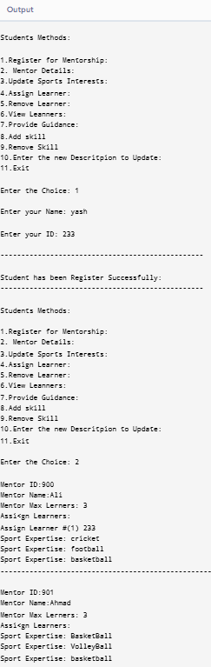

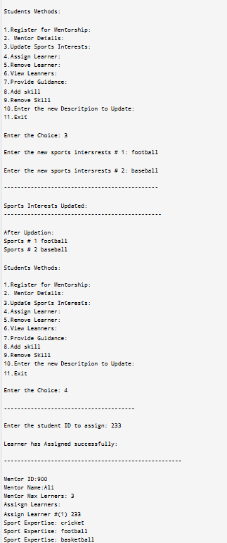

Question#2:
Code:
//Yash Raj
//24k-0737//
#include<iostream>
#include<tuple>//this library will dispaly coordinates into parenthesis//
using namespace std;

class ball {
int x, y;
public:
ball() {
x = 0;
y = 0;
}
int getBallX() {
return x;
}
int getBallY() {
return y;
}
tuple<int, int> getBallPosition() {
return make_tuple(x, y);
}
void move(int dx, int dy) {
x += dx;
y += dy;
}
};

class goal {
int x, y;
public:
goal() {
x = 3;
y = 3;
}
bool isReached(int ballX, int ballY) {
return (x == ballX && y == ballY);
}
};

class robot {
string name;
int hits;
public:
robot(string n) {
name = n;
hits = 0;
}
void hitBall(int& ballX, int& ballY, const string& direction) {
if (direction == "up") {
ballY += 1;
}
else if (direction == "down") {
ballY -= 1;
}
else if (direction == "left") {
ballX -= 1;
}
else if (direction == "right") {
ballX += 1;
}
hits++;
}
string getName() {
return name;
}
int getHits() {
return hits;
}
};

class team {
string teamName;
robot* robo;
public:
team(string team, robot* player) {
teamName = team;
robo = player;
}
string getTeam() {
return teamName;
}
robot* getRobot() {
return robo;
}
};

class game {
team* t1, * t2;
goal g;
ball b;
public:
game(team* t1, team* t2) {
this->t1 = t1;
this->t2 = t2;
}
void play(team* t) {
robot* robo = t->getRobot();
cout<< t->getTeam() << " has started playing!\n";
while (!g.isReached(b.getBallX(), b.getBallY())) {
cout<<"Current ball position: (" << b.getBallX() << ", " << b.getBallY() << ")"<<endl;
cout<<"Enter direction (up, down, left, right): ";
string direction;
cin >> direction;
int ballX = b.getBallX();
int ballY = b.getBallY();
robo->hitBall(ballX, ballY, direction);
b.move(ballX - b.getBallX(), ballY - b.getBallY());
cout<<"Ball moved to: (" << ballX << ", " << ballY << ")" <<endl;
}
cout<<"Goal reached in "<<robo->getHits()<<" hits!"<<endl;
}
void startGame() {
cout<<"Starting the game!"<<endl;
play(t1);
int hits1 = t1->getRobot()->getHits();
b = ball();
play(t2);
int hits2 = t2->getRobot()->getHits();
cout<<"Game Over!"<<endl;
if (hits1 < hits2) cout << t1->getTeam() << " wins!" << endl;
else if (hits2 < hits1) cout << t2->getTeam()<<"wins!"<<endl;
else cout<<"It's a tie!"<<endl;
}
};

int main() {
cout<<"Name: Yash Raj"<<endl;
cout<<"Roll Number: 24k-0737"<<endl;
robot r1("Robot A");
robot r2("Robot B");
team teamOne("Team Alpha", &r1);
team teamTwo("Team Beta", &r2);
game g(&teamOne, &teamTwo);
g.startGame();
return 0;
}

Output:
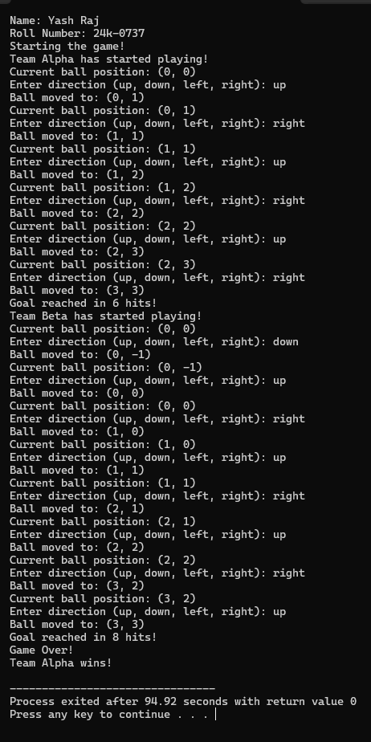

Question#3:
Code:
//Yash Raj//
//24k-0737//
#include <iostream>
#include <string>

using namespace std;

class User {
public:
string name;
int age;
string contact;
int userid;
string licensetype;
User* next;

User(): name(""), age(0), contact(""), userid(0), licensetype(""), next(nullptr) {}

void registerUser() {
cin.ignore();
cout<<"Enter your name: "<<endl;
getline(cin, name);

cout<<"Enter your age: "<<endl;
cin>>age;
cin.ignore();

cout<<"Enter your contact number: "<<endl;
getline(cin, contact);

cout<<"Enter your user ID: "<<endl;
cin>>userid;
cin.ignore();

cout<<"Select your license type (Learner / Intermediate / Full): ";
getline(cin, licensetype);
}

void displayDetails() {
cout<<"User Details: "<<endl;
cout<<"Name: "<<name<<endl;
cout<<"Age: "<<age<<endl;
cout<<"Contact No: "<<contact<<endl;
cout<<"User ID: "<<userid<<endl;
cout <<"License Type: "<<licensetype<<endl;
}
};

class Vehicle {
public:
string model;
double rentalPrice;
string allowedLicense;
Vehicle* next;

Vehicle(string m, double price, string license) : model(m), rentalPrice(price), allowedLicense(license), next(nullptr) {}

void display() {
cout << "Model: " <<model<<endl;
cout<<"Rental Price: " <<rentalPrice<<" Rs per day "<<endl;
cout<<"Required License: " <<allowedLicense<<endl;
}
};

class RentalSystem {
private:
User* userHead;
Vehicle* vehicleHead;

public:
RentalSystem():userHead(nullptr), vehicleHead(nullptr) {}

~RentalSystem() {
while (userHead) {
User* temp = userHead;
userHead = userHead->next;
delete temp;
}

while (vehicleHead) {
Vehicle* temp = vehicleHead;
vehicleHead = vehicleHead->next;
delete temp;
}
}

void addUser() {
User* newUser = new User();
newUser->registerUser();
newUser->next=userHead;
userHead=newUser;
cout<<"User registered successfully!"<<endl;
}

void displayUsers() {
if (!userHead) {
cout<<"No users registered!"<<endl;;
return;
}
User* uPtr = userHead;
while (uPtr) {
uPtr->displayDetails();
uPtr=uPtr->next;
}
}

void addVehicle(string model, double price, string license) {
Vehicle* newVehicle = new Vehicle(model, price, license);
newVehicle->next = vehicleHead;
vehicleHead = newVehicle;
}

void displayVehicles() {
if (!vehicleHead) {
cout<<"No vehicles available!"<<endl;
return;
}
Vehicle* vPtr = vehicleHead;
while (vPtr) {
vPtr->display();
vPtr = vPtr->next;
}
}

void rentVehicle(int userID, string model) {
User* uPtr = userHead;
while (uPtr) {
if (uPtr->userid == userID) {
Vehicle* vPtr = vehicleHead;
while (vPtr) {
if (vPtr->model == model) {
if (uPtr->licensetype == vPtr->allowedLicense) {
cout<<"Vehicle rented successfully!"<<endl;
} else {
cout<<"User is not eligible to rent this vehicle!"<<endl;
}
return;
}
vPtr=vPtr->next;
}
cout<<"Vehicle not found!"<<endl;
return;
}
uPtr=uPtr->next;
}
cout<<"User not found!"<<endl;
}
};

int main() {
RentalSystem rental;

rental.addVehicle("Honda Civic",50,"Intermediate");
rental.addVehicle("Toyota Corolla",45,"Full");
rental.addVehicle("Kia Sportage",30,"Learner");

int choice;
cout<<"Name: Yash Raj"<<endl;
cout<<"Roll Number: 24k-0737"<<endl;
do {
cout<<"Enter your choice:"<<endl;
cout<<"1. Register User"<<endl;
cout<<"2. Display Users"<<endl;
cout<<"3. Display Vehicles"<<endl;;
cout<<"4. Rent a Vehicle"<<endl;
cout<<"0. Exit"<<endl;
cin>>choice;

switch (choice) {
case 1:
rental.addUser();
break;
case 2:
rental.displayUsers();
break;
case 3:
rental.displayVehicles();
break;
case 4: {
int userID;
string vehicleModel;
cout<<"Enter user ID: "<<endl;
cin>>userID;
cout<<"Enter vehicle model: "<<endl;
cin.ignore();
getline(cin, vehicleModel);
rental.rentVehicle(userID, vehicleModel);
break;
}
case 0:
cout << "Exiting program."<<endl;
break;
default:
cout << "Invalid choice."<<endl;
}
} while (choice != 0);

return 0;
}

Output:
Name: Yash Raj
Roll Number: 24k-0737
Enter your choice:
1. Register User
2. Display Users
3. Display Vehicles
4. Rent a Vehicle
0. Exit
1
Enter your name:
yash
Enter your age:
23
Enter your contact number:
009383939
Enter your user ID:
233
Select your license type (Learner / Intermediate / Full): Full
User registered successfully!
Enter your choice:
1. Register User
2. Display Users
3. Display Vehicles
4. Rent a Vehicle
0. Exit
2
User Details:
Name: yash
Age: 23
Contact No: 009383939
User ID: 233
License Type: Full
Enter your choice:
1. Register User
2. Display Users
3. Display Vehicles
4. Rent a Vehicle
0. Exit
3
Model: Kia Sportage
Rental Price: 30 Rs per day
Required License: Learner
Model: Toyota Corolla
Rental Price: 45 Rs per day
Required License: Full
Model: Honda Civic
Rental Price: 50 Rs per day
Required License: Intermediate
Enter your choice:
1. Register User
2. Display Users
3. Display Vehicles
4. Rent a Vehicle
0. Exit
4
Enter user ID:
233
Enter vehicle model:
Kia Sportage
User is not eligible to rent this vehicle!
Enter your choice:
1. Register User
2. Display Users
3. Display Vehicles
4. Rent a Vehicle
0. Exit
0
Exiting program.

Question#4:
Code:
//Yash Raj
//24k-0737//
#include<iostream>
#include<string>
#include<cstdlib>
using namespace std;

class student{
string name;
string rollnumber;
string department;
bool feespaid;
bool transportactivecard;
string ans;
string route;
string pickup;
string dropoff;

public:
student(string name,string rollnumber,string department){
this->name=name;
this->rollnumber=rollnumber;
this->department=department;
this->feespaid= false;
this->transportactivecard= false;
}

void registerfortransport(){
string answer;
cout<<"Do you want to register for transport(Yes/No)"<<endl;
getline(cin,answer);
if(answer=="yes"){
checkfees();
}
else{
cout<<"Exiting the program"<<endl;
exit(0);
}

}
void checkfees(){
cout<<name<<" have you paid your semester fees?"<<endl;
cin>>ans;
cin.ignore();
if(ans=="yes"){
feespaid =true;
activatetransportcard();
booktransport();
}
else {
cout<<"Sorry! "<<name<<" to book your transport you must pay your semester fees"<<endl;
exit(0);
}
}
void booktransport(){
cout<<"Enter your route:"<<endl;
cout<<"1.Clifton"<<endl;
cout<<"2.Tariq Road"<<endl;
cout<<"3.North Nazimabad"<<endl;
cout<<"4.Shahra-e-Faisal"<<endl;
getline(cin,route);
cout<<"Enter your pickup point:"<<endl;
getline(cin,pickup);
cout<<"Enter your drop off point:"<<endl;
getline(cin,dropoff);
cout<<"you have successfully booked your transport for "<<route<<" route"<<endl;
}
void activatetransportcard(){
if(feespaid){
transportactivecard=true;
cout<<name<<" your transport card has been activated! Book your transport:"<<endl;
}
}
void displaydetails(){
cout<<"====Student Details===="<<endl;
cout<<"Name: "<<name<<endl;
cout<<"Roll number: "<<rollnumber<<endl;
cout<<"Department: "<<department<<endl;
cout<<"fees paid(Yes/No):"<<ans<<endl;
cout<<"Route: "<<route<<endl;
cout<<"Pickup point: "<<pickup<<endl;
cout<<"drop off point:"<<dropoff<<endl;

}
string getroute(){
return route;
}
string getname(){
return name;
}
string getrollnumber(){
return rollnumber;
}
};

class driver{
string name;
int driverid;
string number;
string routeassigned;
public:
driver(string name,int driverid,string number){
this->name=name;
this->driverid=driverid;
this->number=number;

}
void assignroute(string route){
this->routeassigned=route;
}
void displaydriver(){
cout<<"=====Driver Details====="<<endl;
cout<<"Driver Name: "<<name<<endl;
cout<<"Driver id: "<<driverid<<endl;
cout<<"Driver phone number: "<<number<<endl;
cout<<"Assigned Route:"<<routeassigned<<endl;
}
string getdrivername(){
return name;
}
};

class bus{
string busnumber;
string stops[3];
int totalstudents;
string busroute;
public:
bus(string busnumber,string stop1,string stop2,string stop3){
this->busnumber=busnumber;
stops[0]=stop1;
stops[1]=stop2;
stops[2]=stop3;
}
void assignroute(string route){
this->busroute=route;
}
void assignstudent(student &s){
cout<<s.getname()<<" with Roll Number "<<s.getrollnumber()<<" is assigned to"<<busnumber<<endl;
}
void recordattendance(student &s){
cout<<s.getname()<<" with Roll Number: "<<s.getrollnumber()<<" has tapped their card"<<endl;
}
void displaydetails(){
cout<<"====Bus Details===="<<endl;
cout<<"Bus Number:"<<busnumber<<endl;
cout<<"Route:"<<busroute<<endl;
cout<<"Stops:"<<stops[0]<<" "<<stops[1]<<" "<<stops[2]<<endl;
}

void tapcard(student &s){
cout<<"Student "<<s.getname()<<" with Roll number"<<s.getrollnumber()<<" has successfully tapped their card"<<endl;
}

};
int main(){
cout<<"Name: Yash Raj"<<endl;
cout<<"Roll Number: 24k-0737"<<endl;
student s1("Yash Raj","24k-0737","cs");
s1.registerfortransport();
s1.displaydetails();

driver d1("wajid",101,"03351242110");
d1.assignroute(s1.getroute());
d1.displaydriver();

bus b1("bus-1232","teen Talwar","Kalapul","Quaidabad");
b1.assignstudent(s1);
b1.assignroute(s1.getroute());
b1.tapcard(s1);
b1.displaydetails();
}

Output:
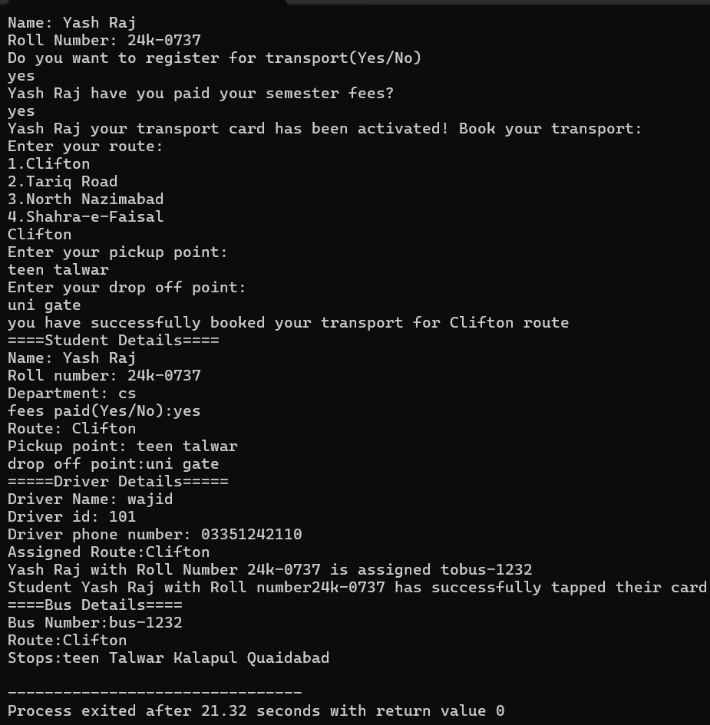
UML DIAGRAM:
